**CP 3**

**Introduction to Monte Carlo Methods**

Nathan Ngqwebo

NGQLIN011

Department of Science, University of Cape Town

PHY2004W | Intermediate Physics

Dr Spencer Wheaton

20 March 2023

**CP 3**

**Introduction to Monte Carlo Methods**

This computational activity is a starter on computational algorithms used for probability distribution function (pdf) sampling and numerical integration. We begin with the Monte Carlo method for approximating . All code was produced using Python (Van Rossum & Drake, 2009) with the packages: NumPy(Harris et al., 2020), and Matplotlib(Hunter, 2007) used for data wrangling and plotting.

**Monte Carlo Data Generation**

Here, we create a histogram of the ‘Activity1Data.txt’ data and ‘fit’ a gaussian curve on the same plot. The histogram bins are made using the integer min, and max values of the dataset. The *arange* function then produces a list of numbers within that range, each one- ‘binwidth’ apart. See Figure 1. The resulting histogram is shown in Figure 2

bins = np.arange(np.floor(min(data)),

                 np.floor(max(data)) + 1, binwidth)

**Figure 1**

*Python Code Sample of the arange Function Call to Produce Histogram Bins*

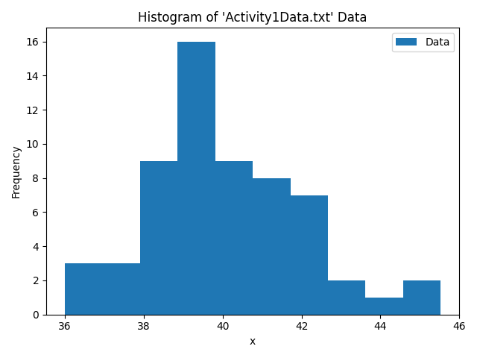**Figure 2**

*Histogram of 60 Samples with and . Bin Width*

To correctly display the gaussian curve over this data, the normal curve definition in (1) needs to be scaled such that the area under the curve is not 1 (in the case of a normal distribution) but is equal to area under the histogram, See (2)

Area under histogram is the summed area of rectangles of width and height (frequency) where is the number of bins.

We can then scale by to produce the plot in Figure 3

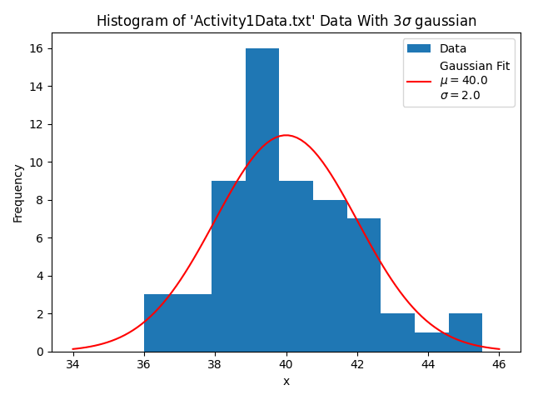**Figure 3**

*Previous Histogram with Plotted Gaussian ‘Fit’*

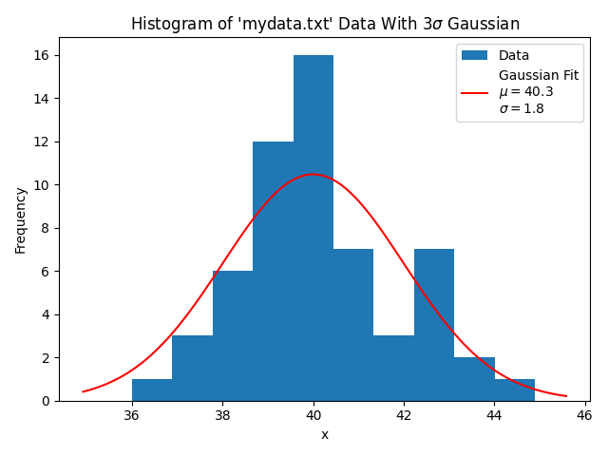Using out own sample of 60 data points with and , we produced Figure 4.

**Figure 4**

*Histogram of ‘mydata.txt’ with Fitted Gaussian Curve.*

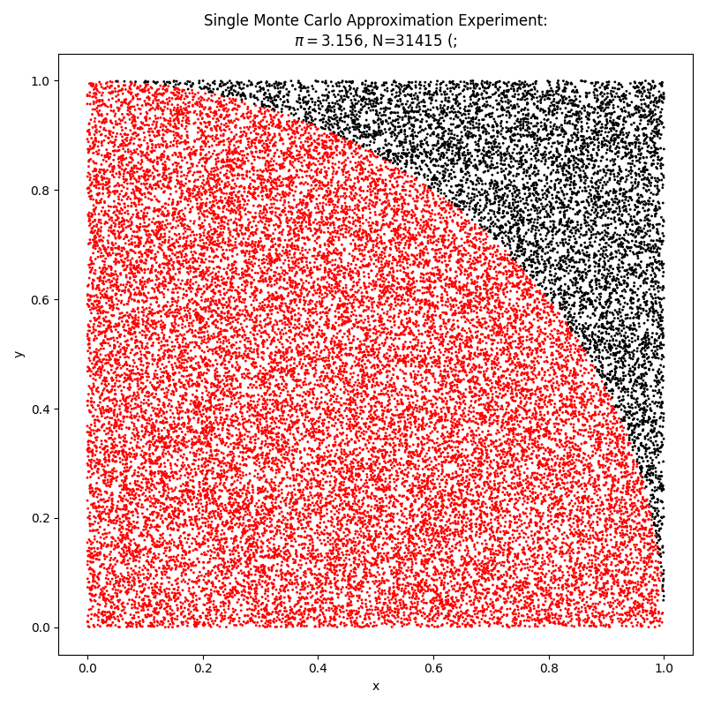**Monte Carlo**  **Approximation**

**Figure 5**

*Visual Example of the Monte Carlo Method for Approximating*

*Note:*The above plot does not represent the actual data used for our measurement. It is only meant as a visual aid.

We present the result of the experimental method outlined in the practical handout where we approximate as four times the ratio of the number of randomly generated points falling within the unit circle to those generated overall, according to (3).

Using NumPy’s vectorization, we were able to perform 50 independent Monte Carlo experiments each with 100,000 uniformly sampled points to calculate our estimate of within a few seconds. This would take a while longer using loop methods.

Using this method, we found to be with a 68% coverage probability, using a Type A uncertainty evaluation, that is, assuming our observations are sampled from an underlying gaussian distribution.

While this value appears accurate to within 3 digits of what we know is the true value, we express concern that the uncertainty of our measurement is significantly underestimated. We believe that the 50 experiments we performed were not entirely independent of each other.

In total, the procedure we used makes total calls to the ‘np.random.uniform’ function producing two 100,000-element arrays of numbers and we are unsure of how NumPy handles multiple such calls using the same random seed.

**References**

Gary, D. E. (n.d.). *H-R Diagram for Stars*. NJIT. Retrieved May 21, 2021, from https://web.njit.edu/~gary/202/Lecture17.html#:~:text=It falls on the %22normal,stars fall along this line.&text=Other stars also get hotter,do not follow these lines.

Ghaye, J. (2015). *Image processing on reconfigurable hardware for continuous monitoring of fluorescent biomarkers in cell cultures*. https://www.researchgate.net/figure/Signal-to-Noise-ratio-versus-exposure-time-of-synthetic-images-We-can-clearly-identify_fig14_283458605

Van Rossum, G., & Drake, F. L. (2009). *Python 3 Reference Manual*. CreateSpace.

Yotti, B. (2021). *Practical Livestream*. https://vula.uct.ac.za/access/content/group/16d4e37d-9842-4a6d-9724-98407cd82199/Practicals/Color Image/GMT20210406-162657_Recording.m4a